Lab 1 Worksheet Sedimentary Rocks and Depositional Environments Spring 2018
Name ______ (-2 points if missing)
Date _______
Use your lab book, lab and lecture PowerPoints, and internet, and your brain as needed to answer all questions in each of the 2 parts. Please explain everything in your own words.
Part 1 Sedimentary Rocks
- Explain the difference between a quartz arenite and a feldspathic arenite.
  - Quartz arenite is composed of less than 90% of siliceous grains that may include quartz, chart, and quartzes rock fragments while Feldspathic contain less than 90% of quartz, have more feldspar than unstable rock fragments and minor amounts of other minerals such as micas and heavy minerals.
- Explain what is meant by provenance
  - It is the source rock of sediments constituents, for instance if you have a sandstone, the provenance would be the source of the quartz grains making up the sandstone
- How do the grains and texture of a clastic rock tell about provenance?
  - Clastic or detrital sedimentary rocks are made up from pieces of bedrock, sediments, derived primarily by mechanical weathering. clastic rocks may also include chemically weathered sediment they are classified by grain shape, size and sorting.
- Describe the difference between an arenite and a wacke.
  - Arenite is any sedimentary rock with a grain size in the sand range on the Wentworth scale while a wacke is (geology) soft earthy dark colored rock or clay derived from the alteration of basalt
- Define each of the following:
  - Skeletal remains
    - Are all that is left of a corpse after nature has taken its course and is disposed of skin, tissue, and any other organ that may cover the skeletal frame normally found buried in shallow graves.
  - Infraclass
    - Are irregularly shaped grains that form by syndepositional erosion of partially lithified sediment, such sediments can contain fragments of early cemented limestone of local origin.
  - Ooids
    - They are small spheroidal coated sedimentary grains usually composed of calcium carbonate, sometimes made up of iron or phosphate based minerals
  - Peloids
    - Its maturated mud or muddy suspension with healing and cosmetic properties composed of a complex mixture of fine grained materials and mineral water
- Explain the difference between a packstone and a grainstone
  - Grain stone are carbonate grains with carbonate cement filling spaces between grains while pack-stone is a mixture of bio clasts and carbonate mud
- Which type of carbonate is a stromatolite?
  - Proterozoic
- In what order do the evaporites develop?
  - Material salts is eroded from land surfaces and is then carried to the sea by water, when sea water evaporates the salts precipitate and settle to the bottom. calcium sulfate forms first followed by sodium chloride.
- How would you classify the rock seen in this image?
  - 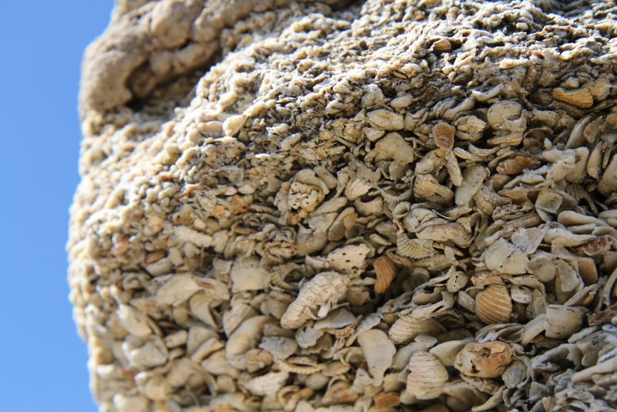
  - It’s a clastic sedimentary rock that is composed of weathered fragments of other rocks

Part 2 Depositional Environments
Use the diagrams in chapter 4, pages 48-58, to answer the following questions. (Caution: images on backside of page from questions)
Part A Figure 4.7 (page 48)
- What is the dominant sedimentary rock type shown in figure 4.7?

  - Magnetite
- What does the red color suggest about the environment of deposition?
  - It shows presence of iron oxide and indicates terrestrial deposition
- Rocks of the North Horn Formation were most likely deposited in which of the sedimentary environments listed in table 4.1. Explain your answer.
  - Ocean water
  - Explain: minerals mostly form in water
Part B Figure 4.8 (page 50)
- What is the dominant sedimentary rock type shown in figure 4.8?
  - Quartz
- What economically important sedimentary rock occurs in this outcrop?
  - Forms minerals like chert flint and jasper
- Rocks of the Blackhawk were most likely deposited in which of the sedimentary environments listed in table 4.1? Explain your answer.
  - Ocean water
  - Explain: this is because minerals develop in ocean water
Part C Figure 4.9 (page 52)
- What two sedimentary rocks types predominate in this formation?
  - Microcrystalline Quartz and flint
- Rocks of the Cedar Mountain formation were most likely deposited in which of the sedimentary environments listed in table 4.1? Explain.
  - Under hot and dry since quartz forms as a result of two components
- Thinking question: Why would dinosaur bones be found more complete in shale than in sandstone.
  - This is because sandstone is easily carried away since its thin and lighter
Part D Figure 4.10 (page 54)
- What is the dominant sedimentary rock type shown in figure 4.10?
  - Orthoclase
- What does the black color suggest about the environment of deposition?
  - Shows presence of carbon impurities
- What additional information is provided by the types of fossils found in the Mancos Shale?
  - The age of the intertongued Dakota sandstone and the Mancps Shale
- Rocks of the Mancos Shale were most likely deposited in which of the sedimentary environments listed in table 4.1? Explain your answer.
  - Hot and dry environment
  - Explain: this is because Mancos shale is hard
Part E Figure 4.11 (page 56)
- How would you describe bedding within the Moenkopi Formation?
  - Calcium rich plagioclases are present in rocks that are dark colored and rich in iron and magnesium like the solidified lavas of haiwaii
- What do the mudcracks (Fig. 4.11E) suggest about the depositional setting?
  - Presence of iron and magnesium
- Rocks of the Moenkopi Formation were most likely deposited in which of the sedimentary environments listed in table 4.1? Explain your answer.
  - Ocean water
  - Explain: this is because they solidify like lava
Part F Figure 4.12 (page 58)
- What do the cross-bedding, presence of crinoids, and politic nature of the limestone indicate about the environment of deposition?
  - The environment contains magnesium and iron

